Human in the loop (HITL)
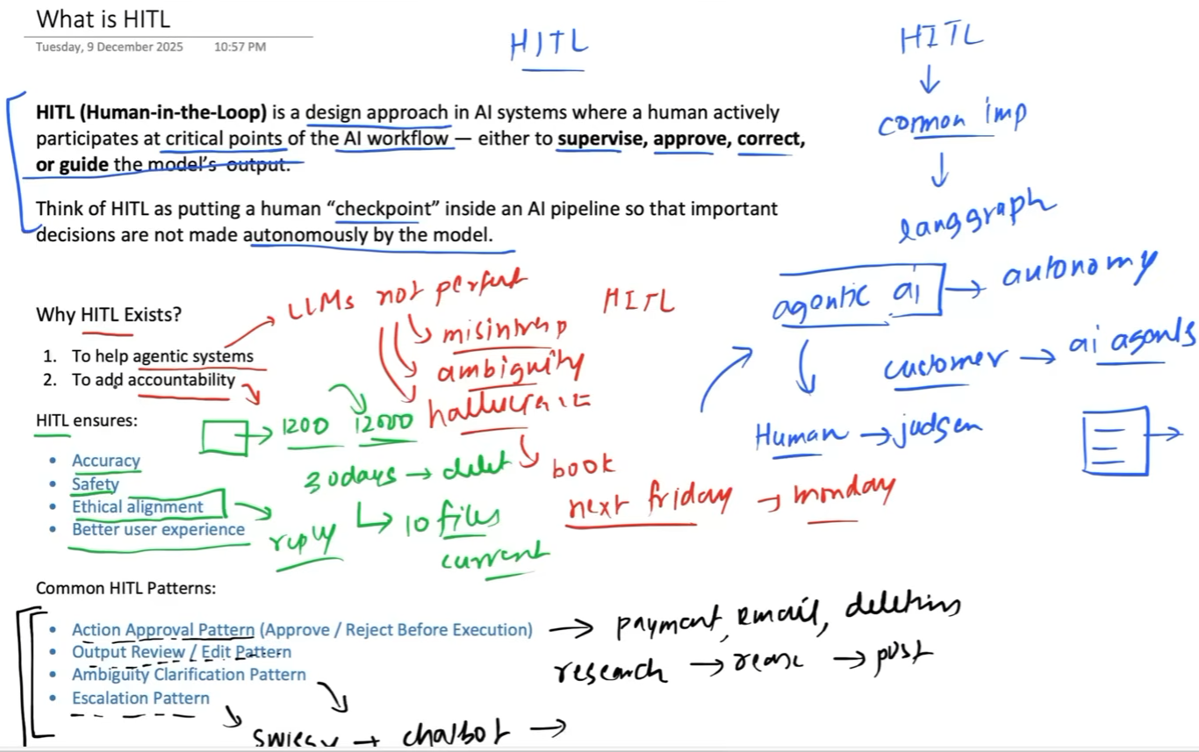
Suppose we are creating a post for a social media website. The LLM generates a draft, and we use the interrupt() function inside the POST node to get human approval before posting.
Explanation:
- The LLM first creates a post/draft.
- Inside the POST node, we use interrupt().
- The decision variable determines whether the post should actually be published:
  - If interrupt() gives Yes, the post is published.
  - Otherwise, the post is rejected.
- When the graph reaches interrupt(), it saves the current state, which includes information such as the topic and the draft, and sends the interrupt information to the frontend.
- The frontend receives the interrupt and asks the user whether they liked/approved the draft or not.
- The user's input is then saved and used to resume the workflow, which comes back to the POST node.
- The decision is checked based on the value returned by the interrupt:
  - Yes → Post the content
  - No → Reject the content
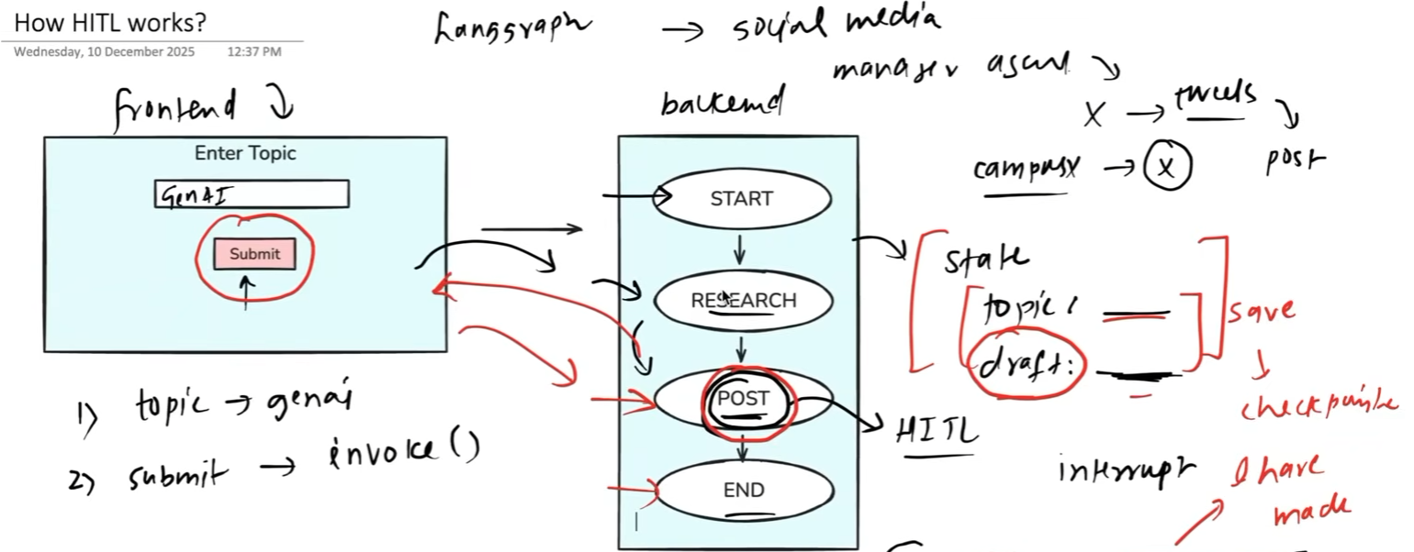
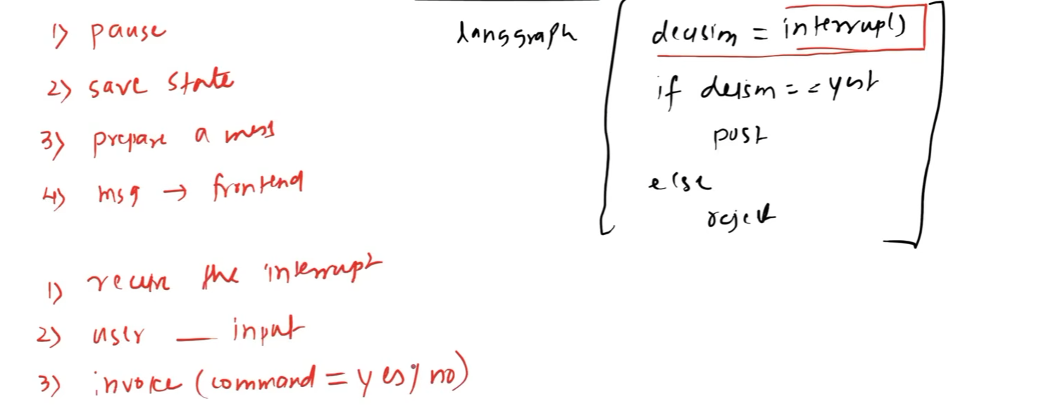

Code:-
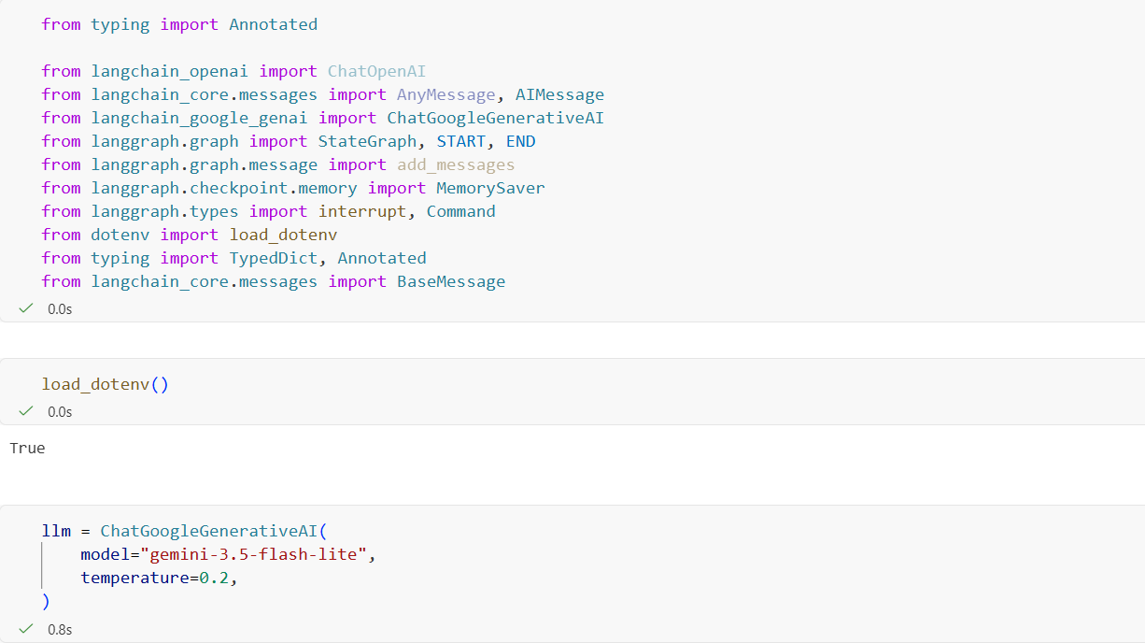
This chat_node() first pauses the workflow and asks for human approval before allowing the LLM to answer the user's question.
Explanation:
- interrupt() pauses the LangGraph workflow and sends the approval request.
- It includes the reason, the current question, and an instruction to approve with yes/no.
- If the decision is "no", the chatbot returns "Not approved."
- If approved, llm.invoke() is called and the LLM generates the response.

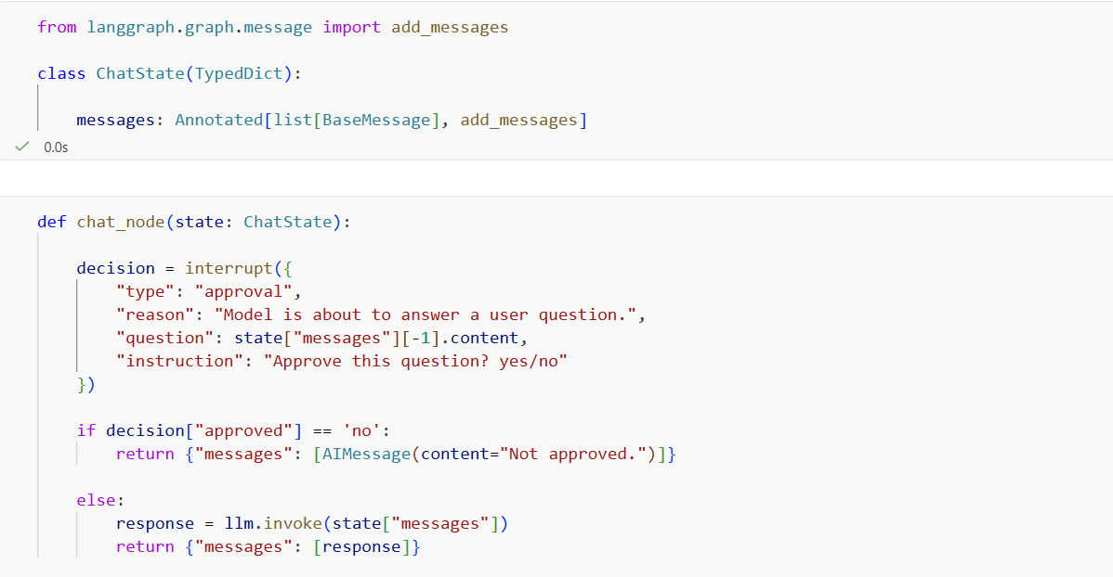
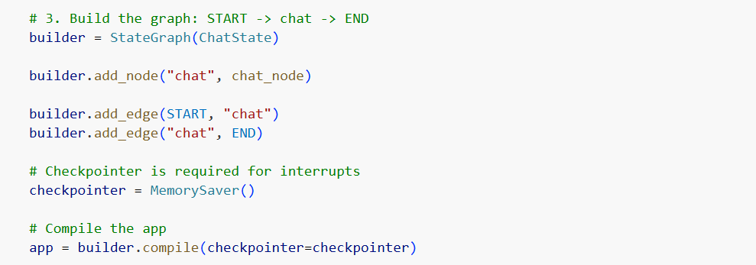
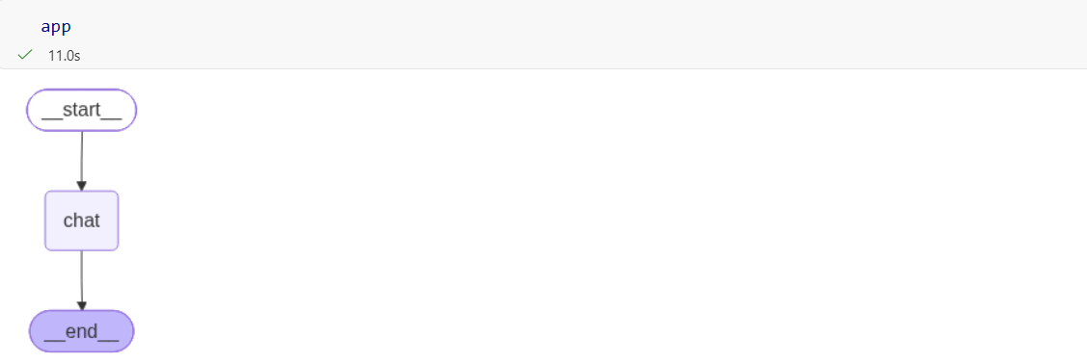
As we can see here, the output contains an interrupt, demonstrating that the workflow has been paused for human input.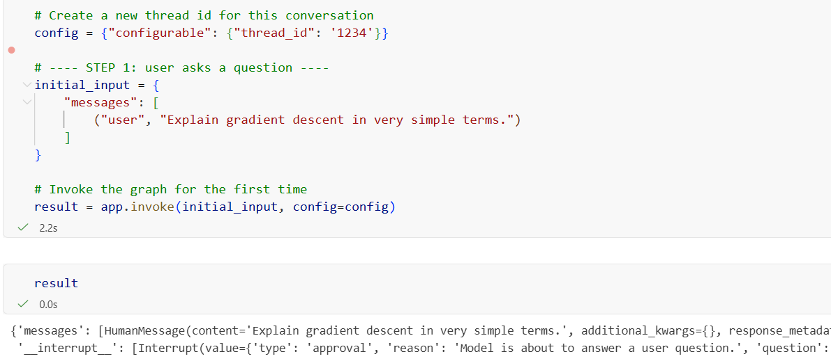
Used to resume an interrupted LangGraph workflow by sending the user's decision back to the interrupt().
Explanation:
- app.invoke() → executes/resumes the graph.
- Command(resume=...) → tells LangGraph to resume from the previous interrupt().
- {"approved": user_input} → sends the user's input as the resume value.
- config=config → identifies the correct workflow/checkpoint, usually using the same thread_id.

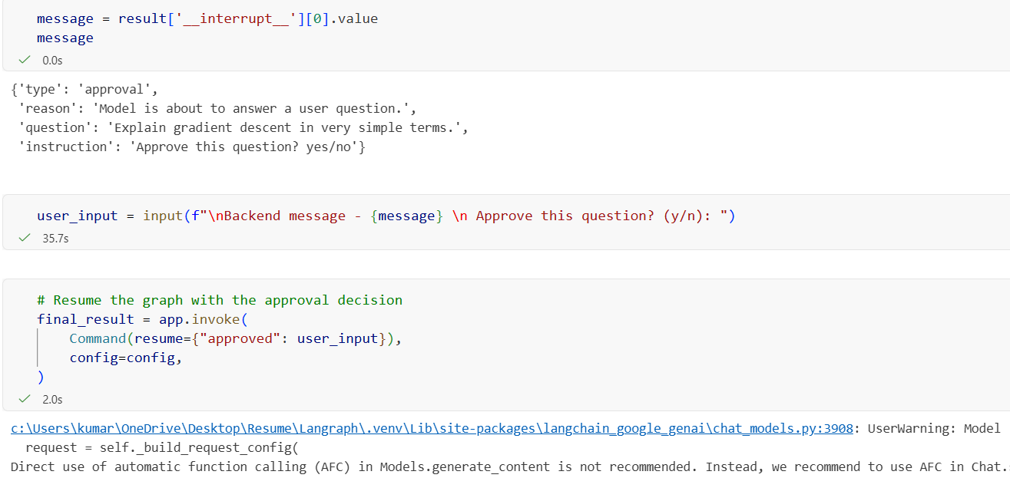
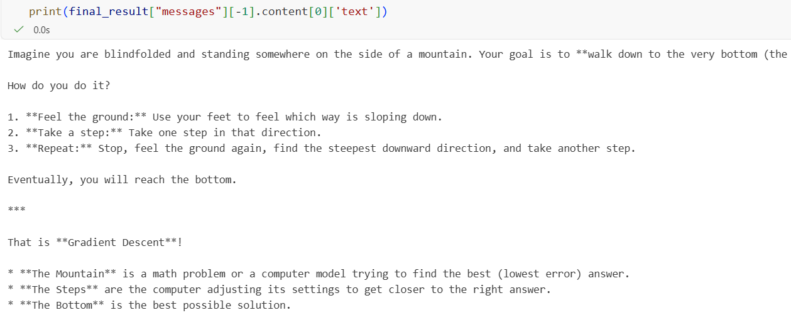

Code:- This is the code of basic chatbot and it has no human involvement.
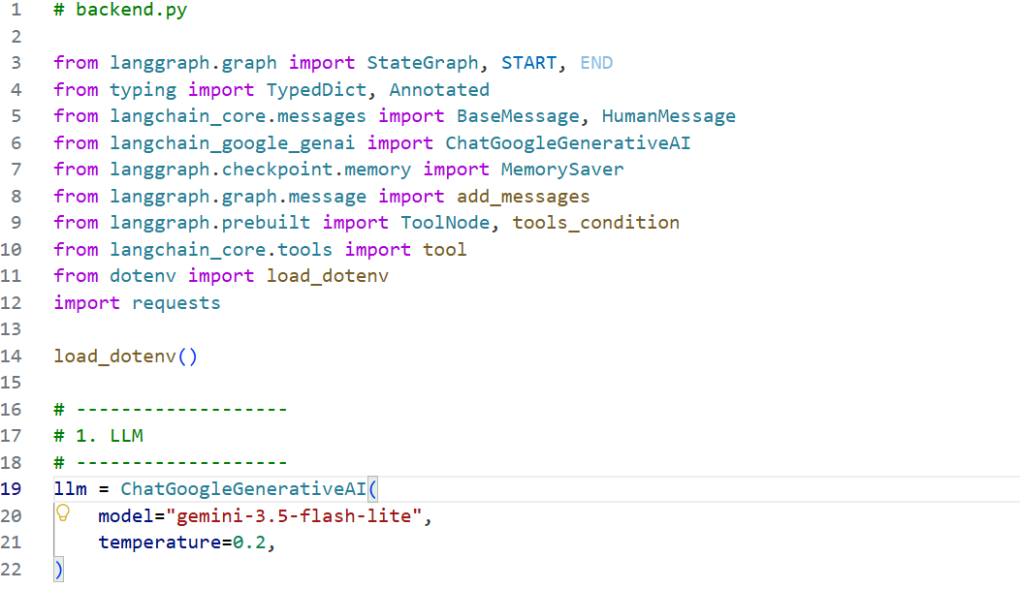
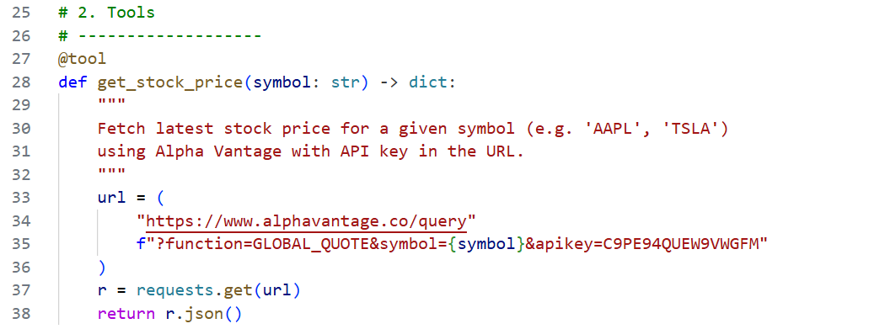
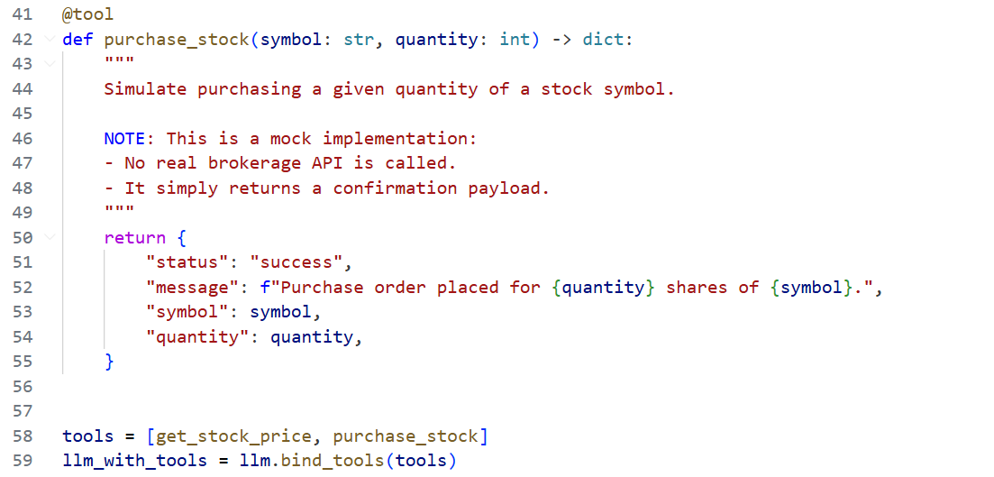
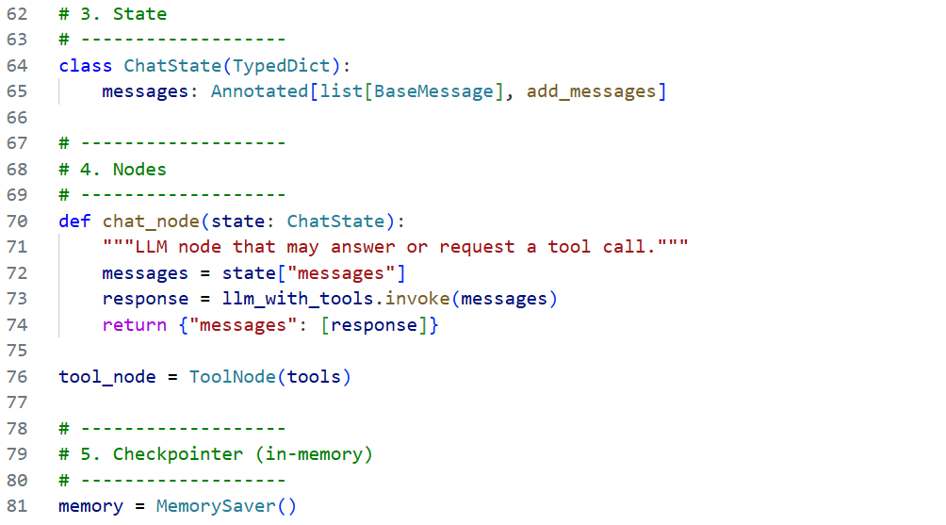
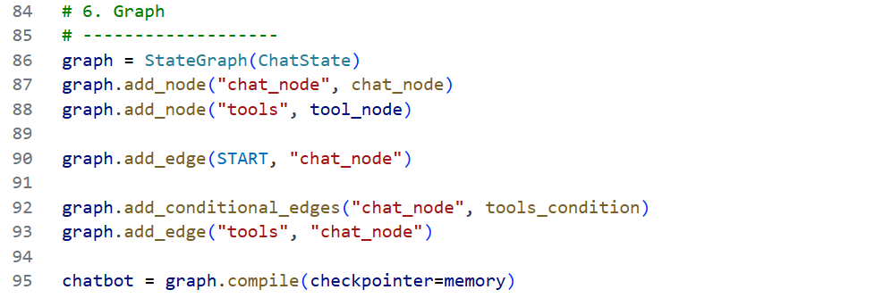
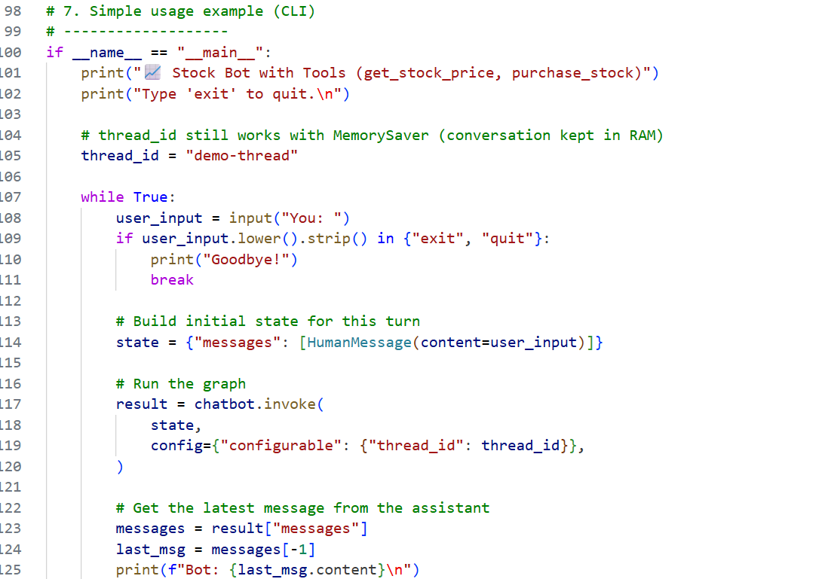

Result:- As we can, an important decision like this is just don’t on its own without any confirmation.
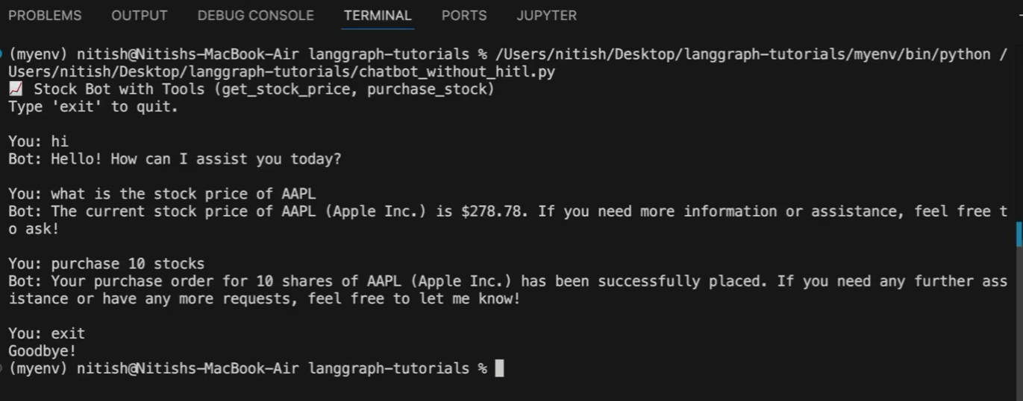

Code:- Now We use HITL in our chatbot
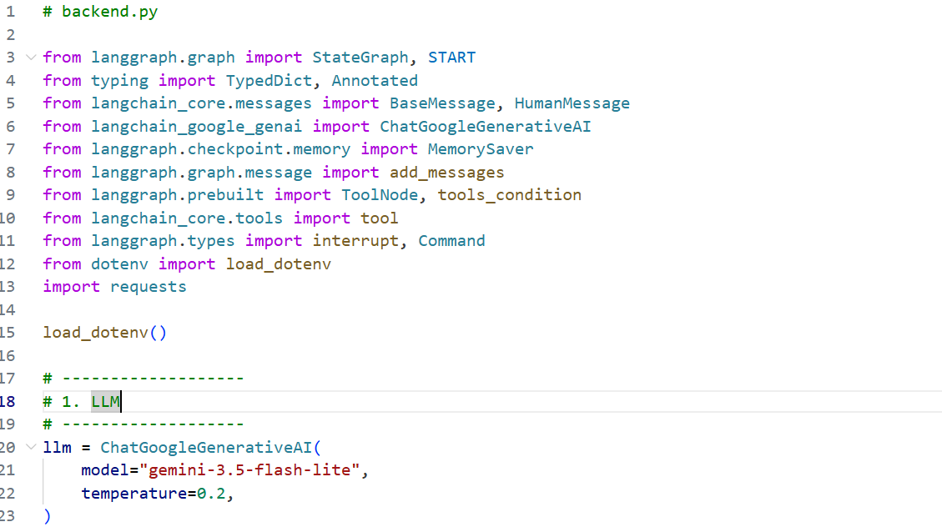
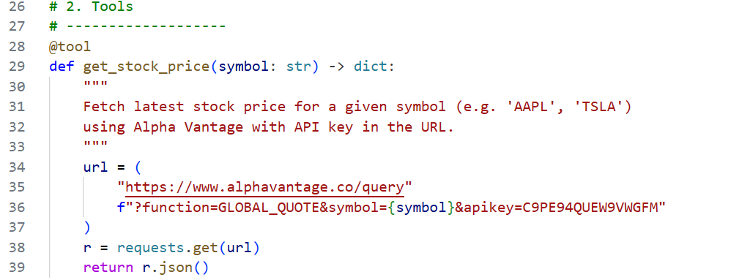
The interrupt() is placed inside the tool, rather than inside the node, as we can see here.
Intuition:
The tool itself pauses and waits for human input, instead of the entire node directly handling the interruption.
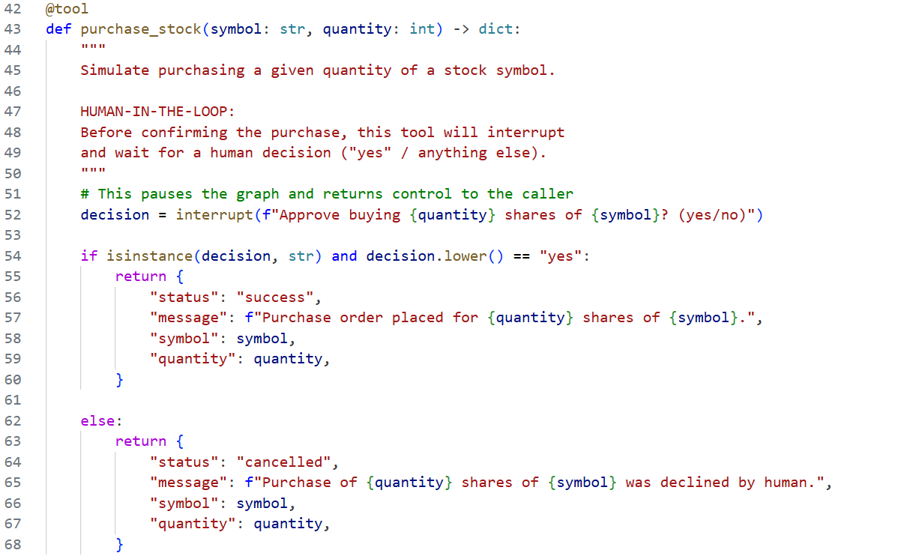
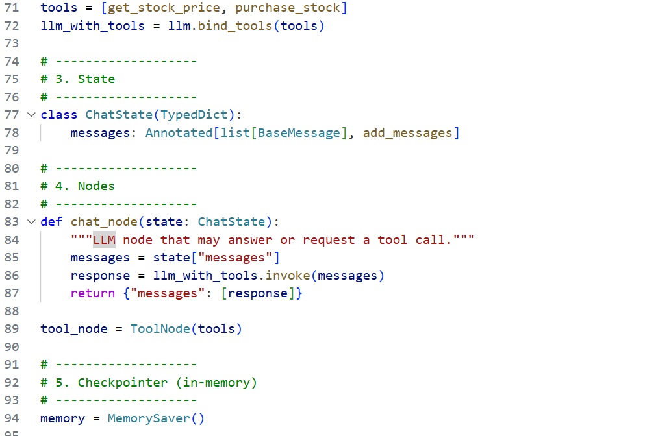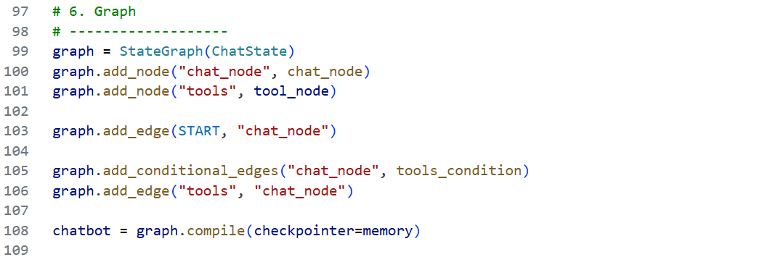
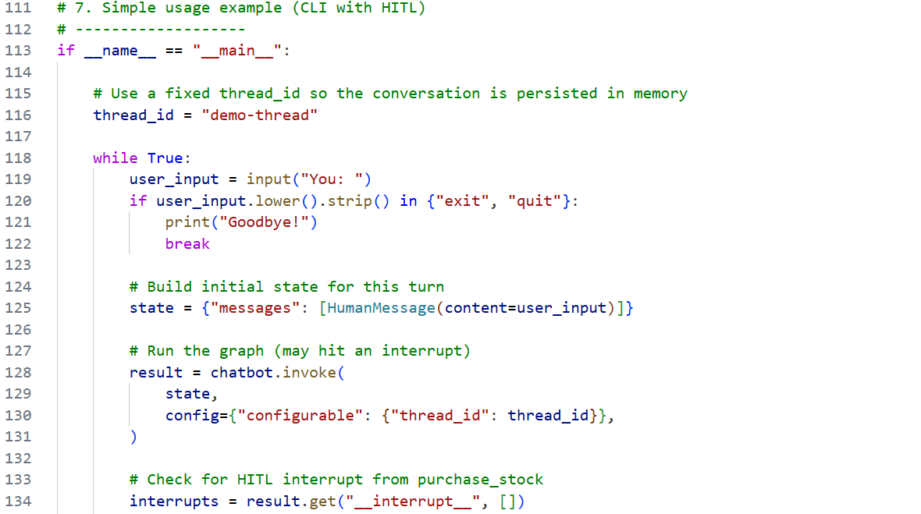
This code checks whether the graph has been interrupted for human-in-the-loop (HITL) input and, if so, displays the interrupt message and asks the human for a decision.
Explanation:
- if interrupts: → checks whether an interrupt exists.
- interrupts[0].value → gets the value/message sent by the interrupt().
- prompt_to_human → stores that message.
- print(...) → displays the message to the human.
- input(...) → waits for the human to enter a decision.
- .strip() → removes extra spaces.
- .lower() → converts the input to lowercase.

Command(resume=decision) - Used to resume the interrupted LangGraph workflow by passing the human's decision back to the interrupt().
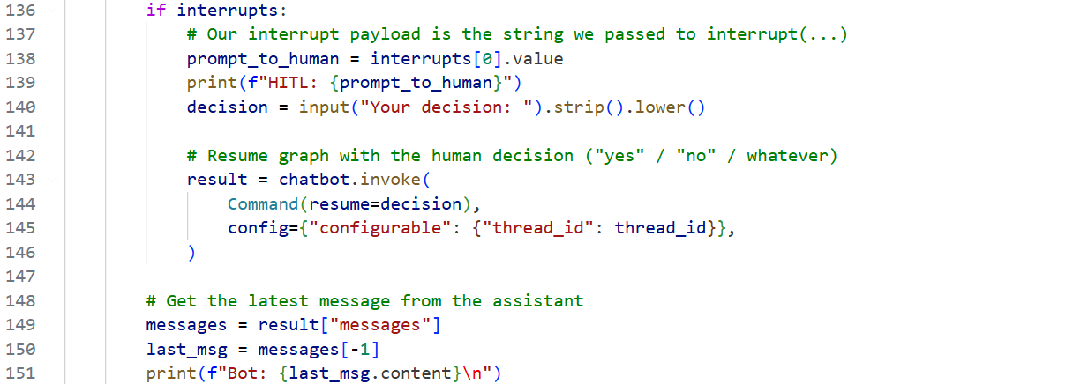
Result:- Here we get a confirmation.
